**MiddleWare**

* When we type an URL in our browser, a request goes to the server and we get a response from server. For the MVC architecture we assume the request goes to controller first, then it processes the request and send a view to the browser.
* But actually, the request first goes through a bunch of components which are known as middleware. 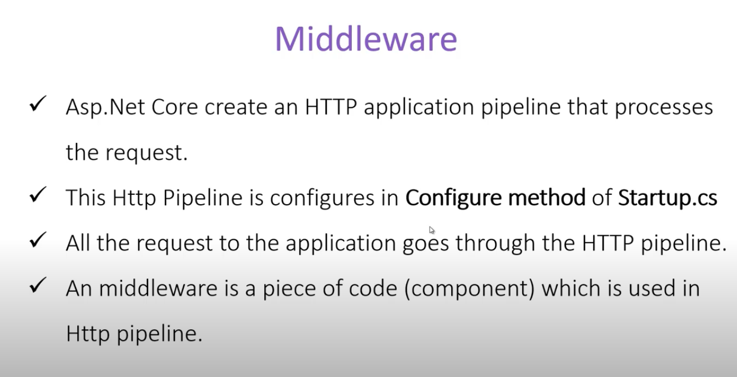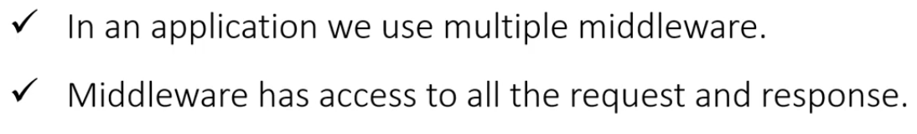

We can use authentication, security or valid request check etc. with the help the middleware.

* In an application we will have multiple middleware. It goes through each middleware, there is some logic and then if next () is called it goes to the next middleware (similar to vanilla node.js). Order is important here. The request is processed first, then response comes. In general, the request is processed as a queue, but the response is more like a stack in a sense since the first middleware response will be the last one.

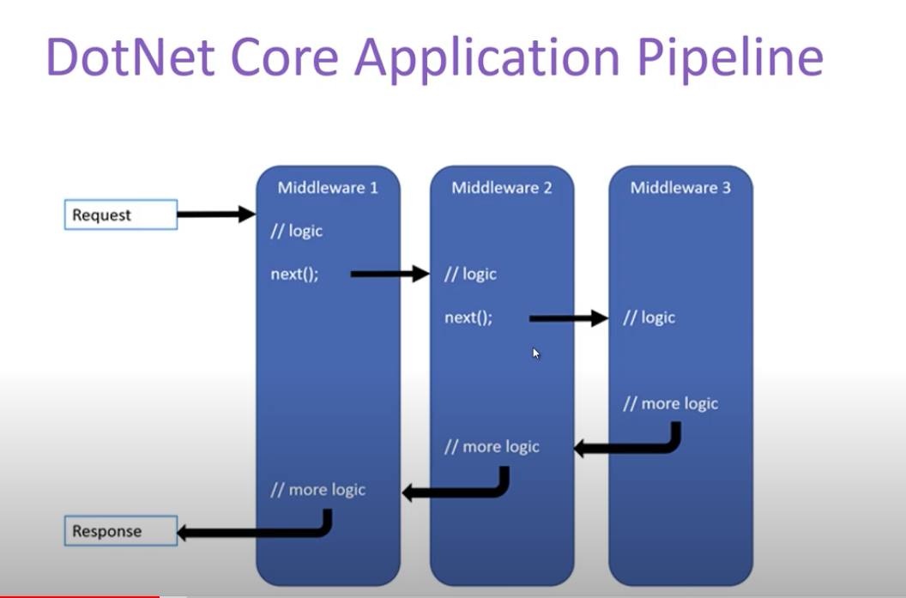

* We can create custom middleware. 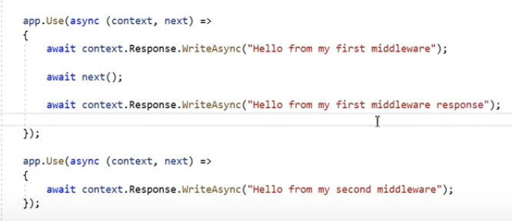

The output will be: 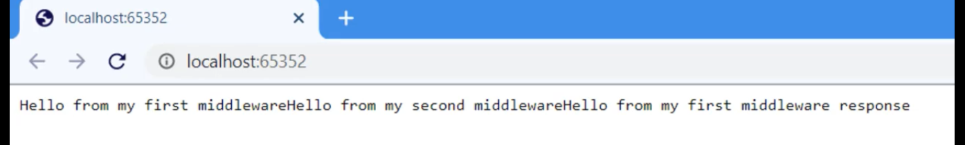

**app.UseRouting()** maps an URL to a particular resource. The resources are defined in the endpoints.